Customer Shopping Behavior Analysis
- Project Overview
This project analyzes customer shopping behavior using transactional data from 3,900 purchases across various product categories. The goal is to uncover insights into spending patterns, customer segments, product preferences, and subscription behavior to guide strategic business decisions.
- Dataset Summary
- Rows: 3,900
- Columns: 18
- Key Features:
- Customer demographics (Age, Gender, Location, Subscription Status)
- Purchase details (Item Purchased, Category, Purchase Amount, Season, Size, Color)
- Shopping behavior (Discount Applied, Promo Code Used, Previous Purchases,
Frequency of Purchases, Review Rating, Shipping Type)
- Missing Data 37 values in Review Rating column
- Exploratory Data Analysis using SQL
We Began with data preparation and cleaning in SQL:
- Data Loading: Imported the dataset into Database.
- Initial Exploration : Used use customer; to check structure select * from customer_shopping_behavior;
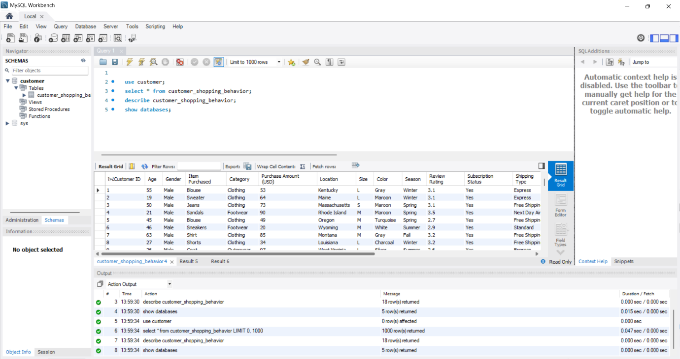

- Checked datatypes of each column : describe customer_shopping_behaviour.
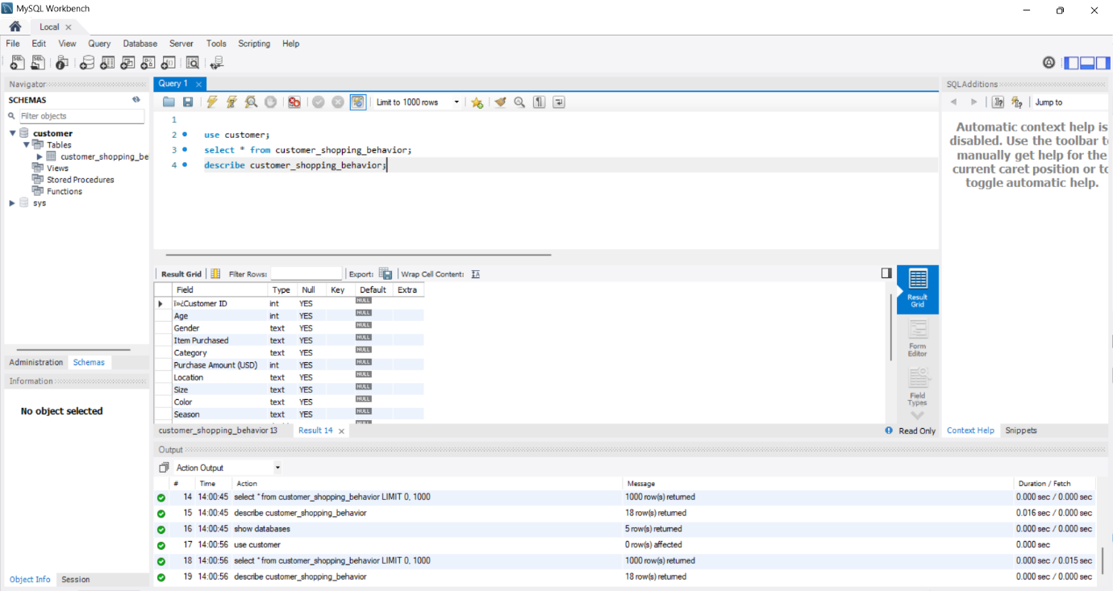

- Exploratory Data Analysis using Python
We began with data preparation and cleaning in python:
- Data Loading : Imported the dataset from Mysql workbench using
mysql-connector-python
- Initial Exploration: Used df.info( ) to check structure .
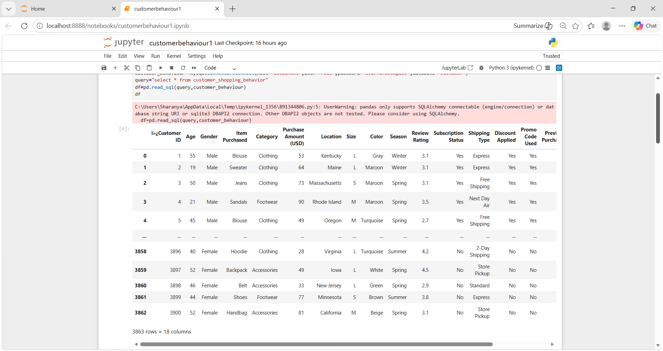
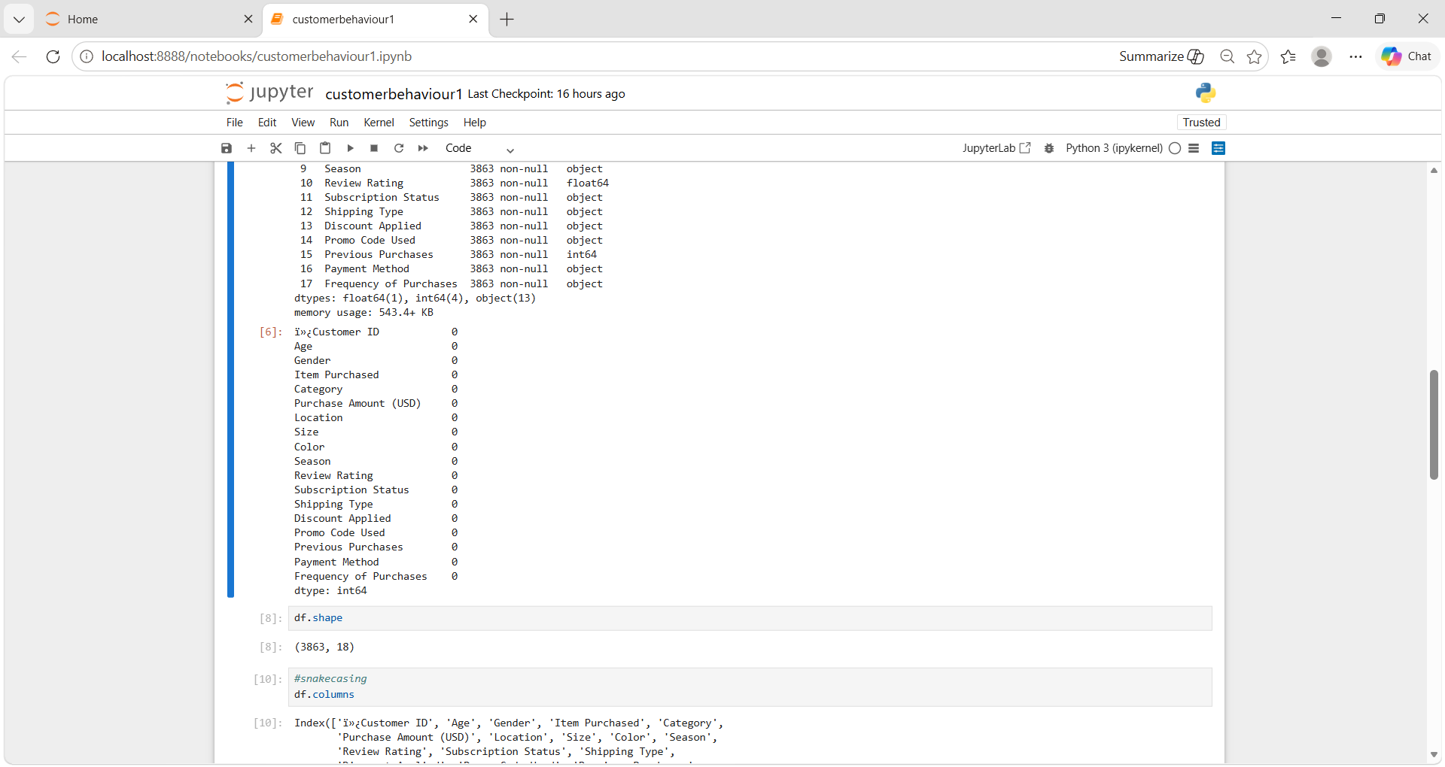
- Missing Data Handling: Checked for null values and no null values.
- Column standardization: Renamed columns to snake case for better readability and documentation.
- Feature Engineering:
- Created age_group column by binning customer ages.
- Created purchase_frequncy_days column from purchase data.

- Dashboard in Power BI
Finally, we built an interactive dashboard in Power BI to present insights visually.
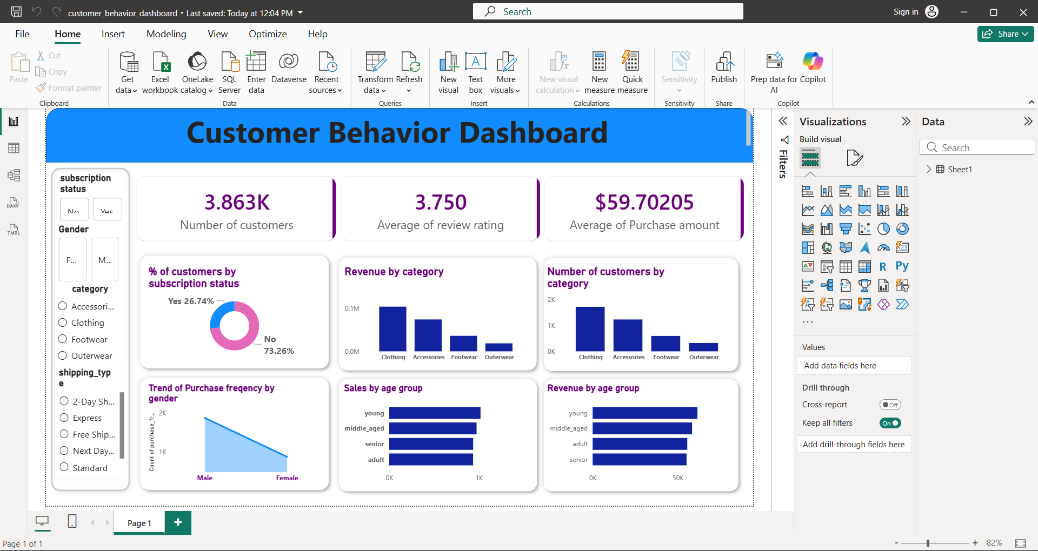
- Business Recommendations
- Boost Subscriptions – Promote exclusive benefits for subscribers,
- Customer Loyalty Programs- Reward repeat buyers to move them into the “Loyal” segment.
- Review Discount Policy- Balance sales boosts with margin control.
- Product Positioning- Highlight top-rated and best-selling products in campaigns.
- Targeted Marketing- Focus efforts on high-revenue age groups and express-shipping users.

